|  |  |
| --- | --- |
| To: | Cabinet |
| Date: | 19 December 2019 |
| Report of: | Head of Financial Services |
| Title of Report: | Treasury Management Mid-Year Review for April – September 2019 |

|  |  |
| --- | --- |
| Summary and recommendations | |
| Purpose of report: | To report on the performance of the Treasury Management function for the 6 months to 30th September 2019 |
| Key decision: | No |
| Executive Board Member: | Councillor Ed Turner, (Deputy Leader) Finance, Asset Management and Public Health |
| Corporate Priority: | None |
| Policy Framework: | Efficient and effective Council |
| Recommendations:That Cabinet resolves to:   1. Note the performance of the Treasury Management function for the six months to 30th September 2019; and 2. Recommend Council to: 3. Approve the change of the Indirect Property Funds counterparty category to Pooled Investment Funds; and 4. Note that the Council is considering investing in a Multi Asset fund instead of an Indirect Property Fund as was previously anticipated. | |

|  |  |
| --- | --- |
| Appendices | |
| Appendix 1 | List of investments as at 30th September 2019 |
| Appendix 2 | Risk Register |
|  |  |

# Introduction and Background

1. This report has been written in accordance with the requirements of the Chartered Institute of Public Finance and Accountancy’s (CIPFA) Code of Practice on Treasury and has been prepared in compliance with CIPFA’s Code of Practice on Treasury Management, covering the following:

* An economic overview for the first part of the 2019/20 financial year
* A review of the Council’s investment portfolio for 2019/20
* A review of the Council’s borrowing strategy for 2019/20
* A statement of compliance with Treasury and Prudential Limits for 2019/20

1. The Council operates a balanced budget, which broadly means cash raised during the year will meet its cash expenditure. Part of the treasury management operations ensure this cash flow is adequately planned, with surplus monies being invested in suitable counterparties, providing adequate liquidity and security initially before considering optimising investment return.
2. The second main function of the treasury management service is the funding of the Council’s capital plans. These capital plans provide a guide to the borrowing need of the Council, essentially the longer term cash flow planning to ensure the Council can meet its capital spending operations. This management of longer term cash may involve arranging long or short term loans, or using longer term cash flow surpluses, and on occasion any debt previously drawn may be restructured to meet Council risk or cost objectives.

**Economic Overview**

1. The over-riding theme for the year so far has been uncertainty and turbulence, mainly down to Brexit which is now expected to happen with some form of deal on the table. The BOE base rate has remained at 0.75% throughout the year, Global economies appear to be slowing and the likelihood of any interest rate rise this year has all but gone with a rate cut now looking more likely in order to support growth. Any interest rate forecasts are subject to material change as the Brexit situation evolves. With so much uncertainty the commercial property market could also be at risk with companies and retailers suffering under the current market conditions.
2. The first half of 2019/20 has seen UK economic growth fall due to the level of uncertainty. In its Inflation Report of 1 August, the Bank of England was notably downbeat about the outlook for both the UK and major world economies. The MPC meeting of 19 September reemphasised their concern about the downturn in world growth and also expressed concern that prolonged uncertainty would contribute to a build-up of spare capacity in the UK economy, especially in the context of a downturn in world growth. This mirrors investor concerns around the world about a significant downturn or possibly even a recession in some major developed economies. It was therefore no surprise that the MPC left the Bank Rate unchanged at 0.75% throughout 2019 so far and they are expected to hold off on changes until there is some clarity on what is going to happen over the EU exit.The new Prime Minister is making some significant promises on various spending commitments and a relaxation in the austerity programme. This will provide some support to the economy and take some pressure off the MPC to cut Bank Rate to support growth.
3. The CPI measure of inflation has been hovering around the Bank of England’s target of 2% during 2019, but fell to 1.7% in August. It is expected to remain close to 2% over the next two years and so it does not pose any immediate concern to the MPC at the current time unless there is a no deal exit where inflation could rise towards 4%, primarily as a result of imported inflation on the back of a weakening pound.

**Interest and Interest Rate Forecasts**

1. The Council’s treasury advisor, Link Asset Services, has provided the following forecast. This forecast includes the increase in margin over gilt yields of 100bps introduced on 9th October 2019.



1. The forecasts in the above table are based on an assumption that there is an agreed EU Exit deal at some point in time. Given the current level of uncertainties, this is a significant assumption and so forecasts may need to be materially reassessed in the light of future events.
2. It has been little surprise that the Monetary Policy Committee (MPC) has left Bank Rate unchanged at 0.75% so far in 2019 due to the ongoing uncertainty over Brexit. Brexit uncertainty has had a dampening effect on UK GDP growth in 2019, especially around mid-year. If there were a no deal Brexit, then it is likely that there will be a cut or cuts in Bank Rate to help support economic growth. The September MPC meeting sounded even more concern about world growth and the effect that prolonged Brexit uncertainty is likely to have on growth. More recently on 7th November the MPC agreed to hold the base rate on a vote of 7 to 2.
3. On 9 October 2019 HM Treasury announced that with immediate effect it was increasing its PWLB borrowing rates. In a statement it reported that “Some local authorities have substantially increased their use of the PWLB in recent months, as the cost of borrowing has fallen to record lows. HM Treasury is therefore restoring interest rates to levels available in 2018, by increasing the margin that applies to new loans from the PWLB by 100bps (one percentage point) on top of usual lending terms.”. The LGA estimate that this increase could costs councils an extra £70 million a year for borrowing to be undertaken in the next year and present a real risk that capital schemes, including vital council house building projects, will cease to be affordable and may have to be cancelled as a result. The impact on the Council is varied. The most significant impact will be on its wholly owned Company Oxford City Housing Ltd.

# Investment Portfolio and Performance

1. The budgeted investment income for 2019/20 is £0.979 million. As at the 30th September 2019, forecast investment income for 2019/20 is £1.474m. There are a number of reasons for the variation but the primary impact is the reduced loans made to the Housing Company due to expected slippage in their capital expenditure plans. This has resulted in larger investment interest as there are more funds deposited than budgeted. The budgeted non treasury housing company loans for 2019/20 were £35.3m, the actual loans as at 30th September 2019 were £1.6m and the forecast outturn is £15.9m. The scope of this report only includes treasury investments therefore the interest that would be received from loans to companies is not included in this report.
2. The Treasury Management Strategy for 2019/20 was approved by this Council in February 2019; to date the Strategy has been fully adhered to. There is one proposed change detailed below.
3. As part of its Strategy, the Council aims to maintain a diversified investment portfolio whilst ensuring there are no policy and procedure breaches. Security of investments is always the primary concern when arranging investments with liquidity and yield being secondary, but key considerations.
4. The Council operates an approved counterparty listing which details all institutions with whom the Council may invest, the maximum amount which may be invested with any single counterparty group at any given point and the maximum duration period. The counterparty list is set in association with recommendations from Link Asset Services although ultimate authorisation of approved counterparties rests with the Section 151 Officer. The list is actively managed and reviewed on a weekly basis or more regularly if required.
5. Monthly monitoring meetings are held with the Section 151 Officer, Financial Accounting Manager and Treasury staff to discuss investments in terms of counterparties and maturity dates, cash flow, interest and borrowing rates and Treasury operational and Strategic strategies.
6. The strategy also adopts an ethical approach to investments, stating that:

*“The Council will not knowingly invest directly in businesses whose activities and practices pose a risk of serious harm to individuals or groups, or whose activities are inconsistent with the Council’s mission and values. This would include, inter alia, avoiding direct investment in institutions with material links to:*

* *Human rights abuse (e.g. child labour, political oppression)*
* *Environmentally harmful activities (e.g. pollutants, destruction of habitat, fossil fuels)*
* *Socially harmful activities (e.g. tobacco, gambling)”*

1. The Council has been able to take advantage of some further green deposit notice accounts offered by Barclays Bank who are working in association with Sustainanalytics, a leading global provider of environmental, social and corporate governance research and ratings, to achieve a positive environmental impact. Their green framework covers the following environmental areas:

* Energy efficiency projects and renewable energy
* Sustainable food agriculture and forestry
* Waste management
* Greenhouse gas emission reduction
* Sustainable water

1. The Council currently has £7.5 million in these accounts.

# Property Funds

1. At present, the Council has placed investments with two property funds; CCLA Investment Management, which is a property fund that limits its investors to Charities, Churches and Local Authorities and Lothbury Investment Management, a specialist UK property fund manager with a range of funds providing high quality exposure to different property sectors.

**CCLA Investment Management Limited**

1. The Council has held a £3m investment in the CCLA fund since September 2013. The investment has produced quarterly returns ranging between 5% and 6% and it is expected that the Fund will continue to achieve rates in this region.
2. Additionally, the value of the Council’s investment with CCLA has appreciated from £3m to £3.86m as at 30th September 2019, equating to growth of 28.7% to date. However, the values of the individual unit prices have fluctuated over time and the effect of capital appreciation (and depreciation) is illustrated in the graph below.

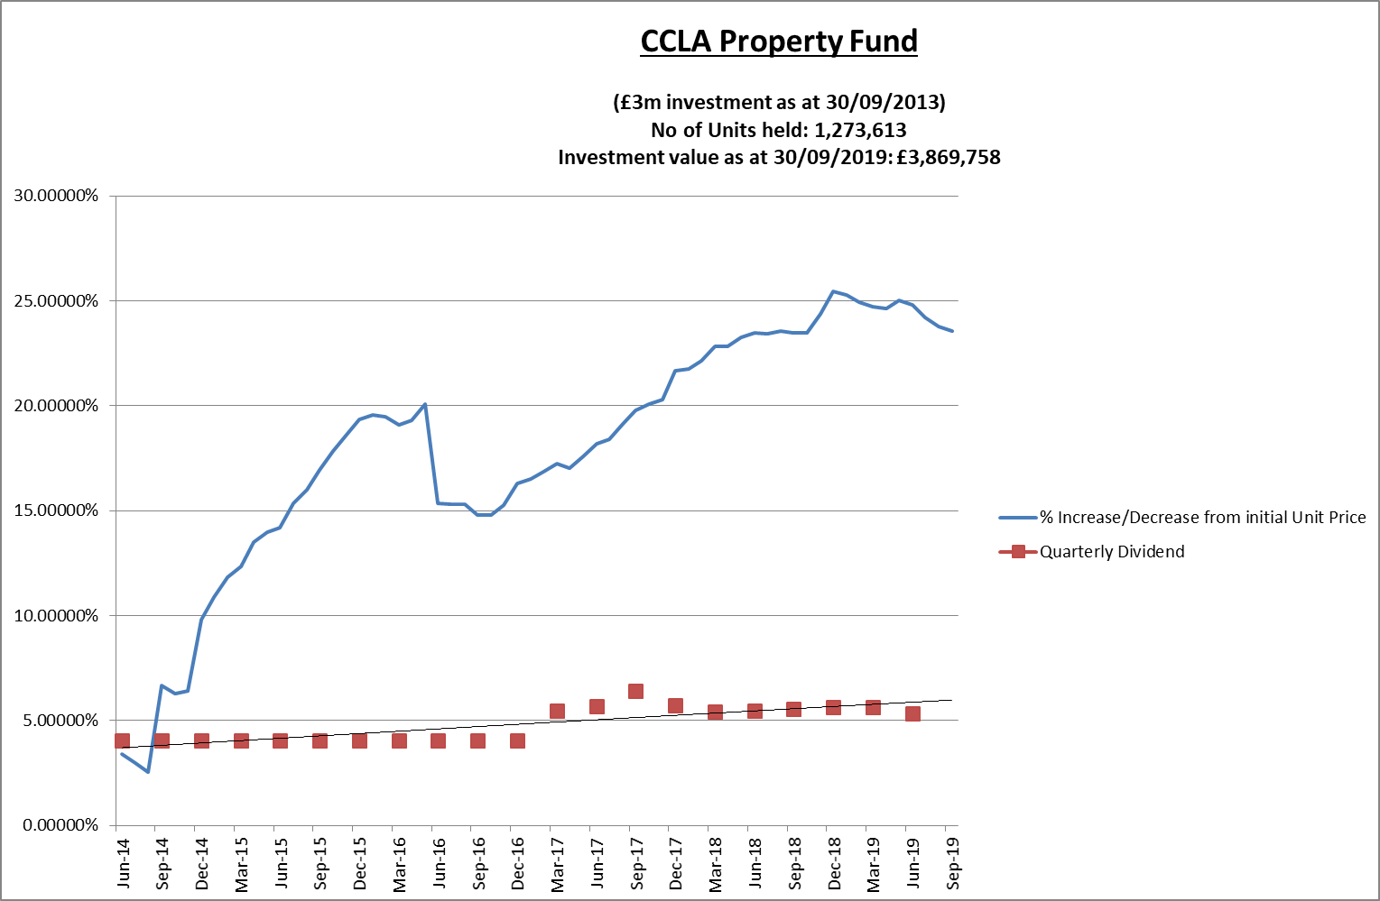

1. Changes to the accounting rules on property funds means that the principal gain or loss will now be charged to the Surplus or Deficit on the Provision of Services, within the Councils Income and Expenditure Account, rather than being held on the balance sheet. However, following consultation by MHCLG the government has introduced a mandatory statutory override for local authorities to reverse out the effect for five years from 1st April 2018 after which surpluses as well as deficit will impact on the Councils revenue position. Even without the statutory override, the Council would have created a reserve to hold the funds until the return was realised due to the potential for fluctuations in the property markets.
2. The investment returns around £40k per quarter.

**Lothbury Investment Management**

1. During 2014/15, the Council invested £7m in the Lothbury Property fund and the Fund has produced quarterly returns in the range of 3-4%. Furthermore, the Fund has seen a capital appreciation over the period with the value currently standing at £8.39m, compared with £7m at inception, equating to overall growth of 19.79% to date. However, as with CCLA, the values of the individual unit prices have fluctuated over time and the effect of capital appreciation (and depreciation) is illustrated in the graph below. The changes to accounting rules will also affect the Lothbury Property Fund as explained in paragraph 21 above.

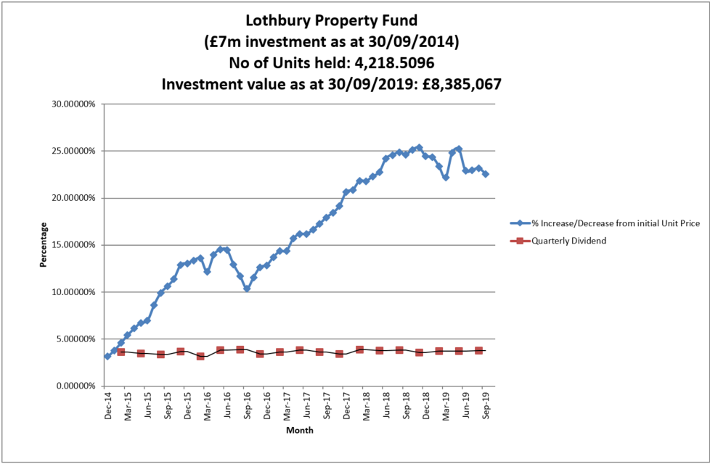

The investment returns around £64k per quarter.

**Investment Portfolio**

1. As at 30th September, the Council’s total investment portfolio amounted to £112.5m, with £10m of this being held in property funds and £14m being held in instant access cash facilities with the balance being held in banks and building societies
2. The graphs below illustrate how Council’s investment portfolio is distributed, both in terms of the type of investment and counterparty category:

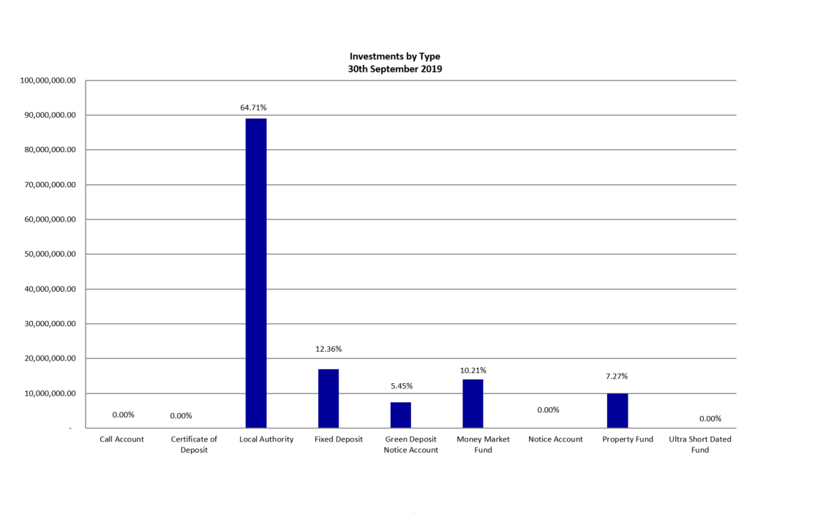

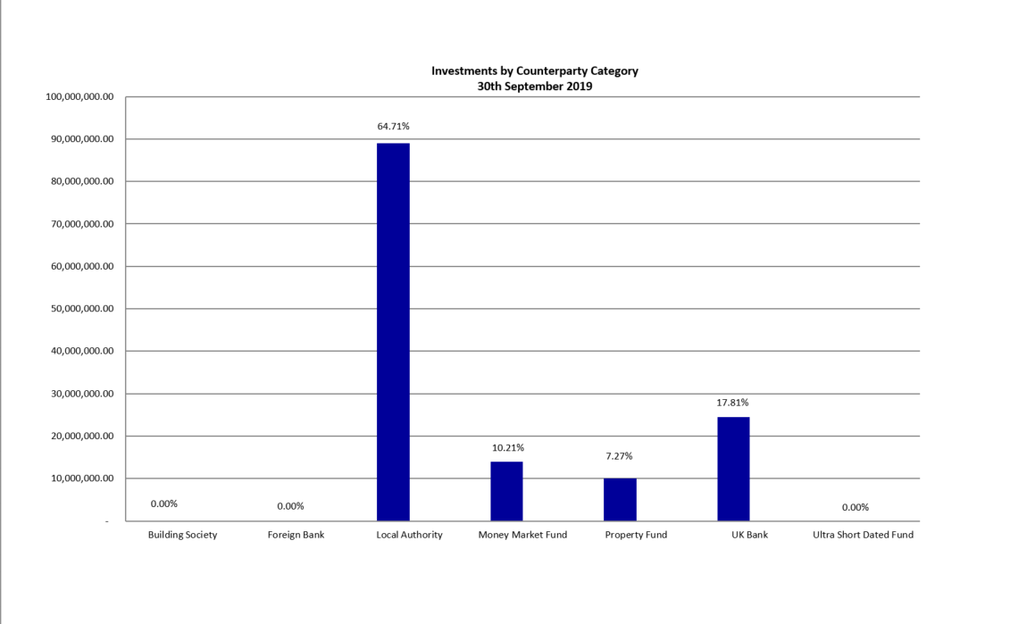

1. Fixed deposits and certificates of deposits both have an agreed start and end date which are arranged where possible, to suit the cashflow requirements. However, as mentioned previously, it is also important to keep a proportion in instant access funds.
2. The Council’s Treasury Management Strategy limits non-specified investments to 25% (or £25m whichever is greater) of the previous year’s average investment portfolio. This limit is reviewed each year when setting the Strategy in order to ensure a balanced and diversified portfolio of investments. Property funds and investments in excess of 364 days are classified as non-specified due to the associated risk; property funds by nature are high risk due to the volatility of the market. There are several factors that deem longer term investments to be more risky in nature including the risk of interest rate rises and the commitment of cash for longer periods.
3. £10 million is committed in the CCLA and Lothbury property funds and we are currently looking at utilising residual headroom to invest further in some non-specified investments. It should be noted that the £5 million invested in the National Homelessness Property Fund (Real Lettings) is, following discussions with our external auditors, classified as a service investment undertaken using service delivery powers rather than treasury powers under Section 12 of the Local Government Act 2003. This means the counterparty limit for the £5m invested in the National Homelessness Property Fund is not taken into account when assessing the residual headroom available for investment in non-specified investments.
4. The Strategy defines a specified investment as one that is in sterling, no more than one year in duration or, if in excess of one year can be repaid earlier on request and with counterparties that meet the Council’s credit rating criteria. Additionally, once the duration of a non-specified investment falls below 366 days, it also falls into the Specified category. The maturity profile for the Council’s specified investments (equating to £88.5m when excluding the instant access cash) is illustrated below.

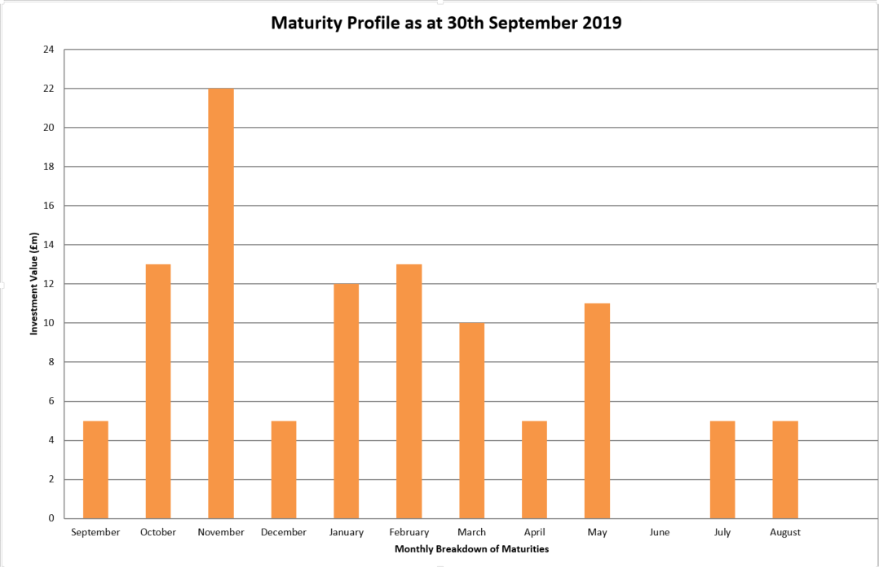

1. The graph below illustrates the same investments by duration period in order to demonstrate duration periods. It is not surprising that the majority of investments have a duration period of six months as this is the limit for most of the banks and building societies with whom the Council may invest. When the opportunity arises, longer investments are arranged to allow for a greater yield.

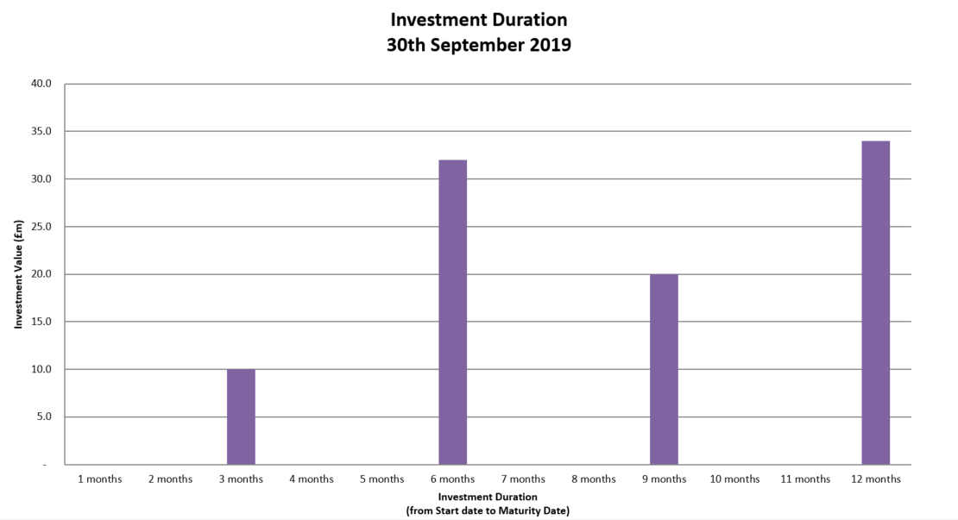

**Borrowing**

1. The Council has not taken on any additional debt during the year to date and so the balance of its external borrowing remains at approximately £198.5 million; this figure relates to funds borrowed from the Public Works Loans Board (PWLB) to buy out the Housing Revenue Account (HRA) from the subsidy system and relates wholly to Housing with interest repayment being met by the HRA. The Council does not consider that debt restructuring and/or premature repayment would be practical at this time as due to the differential in interest rates, the Council would incur a large premium from the PWLB for doing so. The Council continues to monitor borrowing interest rates and forecasts on a regular basis and will continue to review its position on debt restructuring.
2. The Council anticipates borrowing in the future to meet its capital expenditure requirements, including loans to the Housing Company, but does not anticipate any external borrowing during 2019/20.

**Treasury and Prudential Limits for 2019/20**

1. The Council has operated all of its Treasury Management activity within the parameters set by the Treasury and Prudential indicators in the Treasury Management Strategy for 2019/20.

**Proposed Change to Counterparty Lists**

1. The consultation budget presented to City Executive Board on 18th December 2018 and ratified at the City Executive Board meeting of 12th February 2019 and Council of 13th February 2019 included a proposal to make a further £10 million investment in property funds. This is within the counterparty limits of the 2019/20 treasury strategy as per the non-specified counterparty limit shown below:

|  |  |  |  |
| --- | --- | --- | --- |
|  | **Minimum Credit Criteria** | **Max % of total investments/£ limit per institution** | **Max maturity period** |
| Indirect Property funds |  | 25% of total investments or £24 million, whichever is the greater | Medium to long term |

1. In order to provide greater diversification within the treasury investment portfolio, it is proposed to consider investing in a Multi Asset fund instead. This would reduce the Council’s reliance on property based income and therefore reduce exposure to this sector. The Council has been advised by their treasury advisors, Link Asset Services, that the financial returns from these types of funds are similar and so there would be no adverse effect on the budgets already approved. It is therefore proposed to amend this counterparty limit to cover Indirect Property Funds and Multi Asset funds.

**Other Key Updates**

**Changes in Risk Appetite**

1. The 2018 CIPFA Codes and guidance notes have placed enhanced importance on risk management. Where an authority changes its risk appetite e.g. for moving surplus cash into or out of certain types of investment funds or other types of investment instruments, this change in risk appetite and policy should be brought to members’ attention in treasury management update reports. Oxford City Council has not made any significant changes to its investment approach at this time although there is the intention to further invest in property funds in the near future. The risk will continue to be managed by understanding the individual investment vehicles and also by considering the appropriate percentage of non-specified investments that can be held in the overall portfolio.

# Treasury Advisor

1. Treasury advice and market information is provided by Link Asset Services. Information provided by Link Asset Services is used to advise Council Officers when making investment decisions.

# Financial Implications

1. Any financial implications are contained within the body of this report.

# Legal Issues

1. There are no legal implications directly relevant to this report.

# Level of Risk

1. There are no risks in connection with the report’s recommendations. Risk assessment and management is a key part of Treasury Management activity especially in the selection of counterparties when considering investment opportunities. The Council uses external advisors and counterparty credit ratings issued by the rating agencies to assist in this process.

# Equalities Impact

1. There are no equalities impacts arising directly from this report.

|  |  |
| --- | --- |
| **Report author** | Bill Lewis |
| Job title | Financial Accounting Manager |
| Service area or department | Financial Services |
| Telephone | 01865 252607 |
| e-mail | blewis@oxford.gov.uk |

|  |
| --- |
| Background Papers: None |